EXP4: Cryptarithmetic Problem
Name: Y. Roshitha (192424400)

Aim:
To develop a Python program that solves the Cryptarithmetic Problem (SEND + MORE = MONEY) using a brute-force permutation search, assigning a unique digit to each letter such that the resulting arithmetic equation holds true.

Algorithm:
Step 1: Identify the distinct letters involved in the equation SEND + MORE = MONEY.
Step 2: Generate the next permutation of digits (0-9) for the letters.
Step 3: Check that the leading letters (S and M) are not assigned the digit 0.
Step 4: Compute the numeric values of SEND, MORE, and MONEY using the current digit assignment.
Step 5: Check whether SEND + MORE equals MONEY.
- If satisfied -> record the mapping and print the solution.
- If not satisfied -> discard the mapping and try the next permutation.
Step 6: Repeat Steps 2-5 until a valid assignment is found or all permutations are exhausted.
Step 7: Display the digit assigned to each letter and the resulting arithmetic equation.

Source Code:
from itertools import permutations

def solve_cryptarithmetic():
letters = ['S', 'E', 'N', 'D', 'M', 'O', 'R', 'Y']

for perm in permutations(range(10), len(letters)):
mapping = dict(zip(letters, perm))

if mapping['S'] == 0 or mapping['M'] == 0:
continue

send = (mapping['S'] * 1000 + mapping['E'] * 100 +
mapping['N'] * 10 + mapping['D'])
more = (mapping['M'] * 1000 + mapping['O'] * 100 +
mapping['R'] * 10 + mapping['E'])
money = (mapping['M'] * 10000 + mapping['O'] * 1000 +
mapping['N'] * 100 + mapping['E'] * 10 + mapping['Y'])

if send + more == money:
return mapping, send, more, money

return None

result = solve_cryptarithmetic()

print("Solving Cryptarithmetic Problem: SEND + MORE = MONEY\n")
if result:
mapping, send, more, money = result
for letter in ['S', 'E', 'N', 'D', 'M', 'O', 'R', 'Y']:
print(f"{letter} = {mapping[letter]}")
print()
print(f" {send}")
print(f"+ {more}")
print(f"-----")
print(f" {money}")
else:
print("No solution found.")

Flowchart:

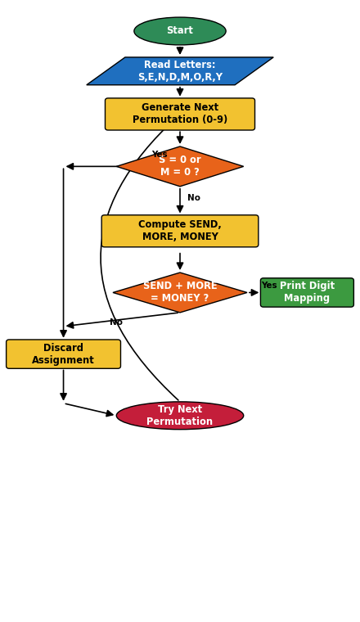

Output:

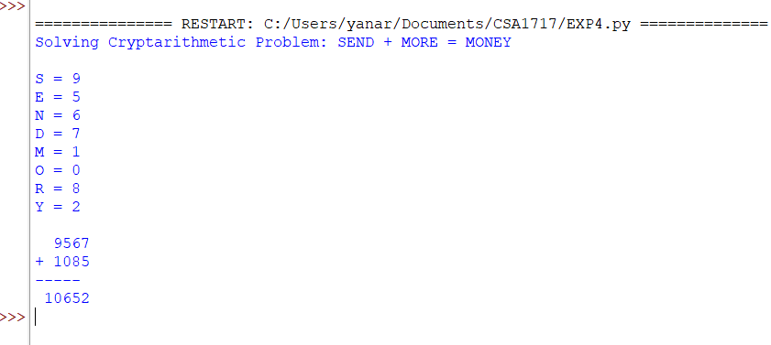

Result:
The Cryptarithmetic program successfully found a valid digit assignment for the letters S, E, N, D, M, O, R, and Y such that the equation SEND + MORE = MONEY held true. The brute-force permutation search systematically tried digit combinations and discarded those that violated the leading-zero constraint or failed to satisfy the equation.
The program displayed the digit assigned to each letter and printed the resulting numeric equation, confirming that 9567 + 1085 equals 10652.
Thus, the Cryptarithmetic Problem was solved successfully using the brute-force permutation search algorithm.

